**18BCS037 Ganesh Sethu**

**1) MARKET BASKET ANALYSIS dataset**

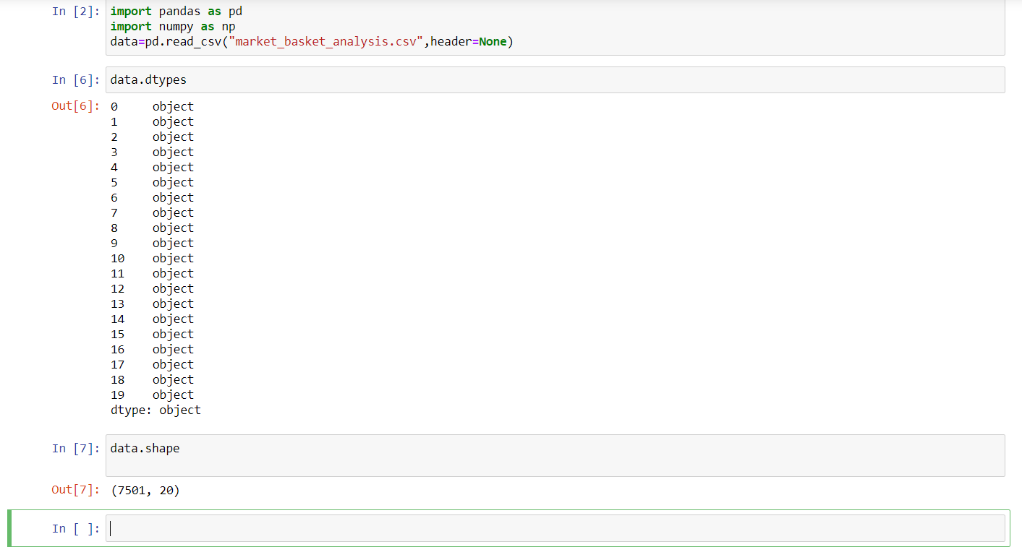

The dataset has 7501 records(rows) where each record is a individual transaction of items bought by the customer, there are maximum of 20 items bought in one transaction henceforth the number of columns in the dataset is 20,i have used shape method above to showcase the above explanation. Each column is of type object which can be inferred using dtypes method.

2) ans:

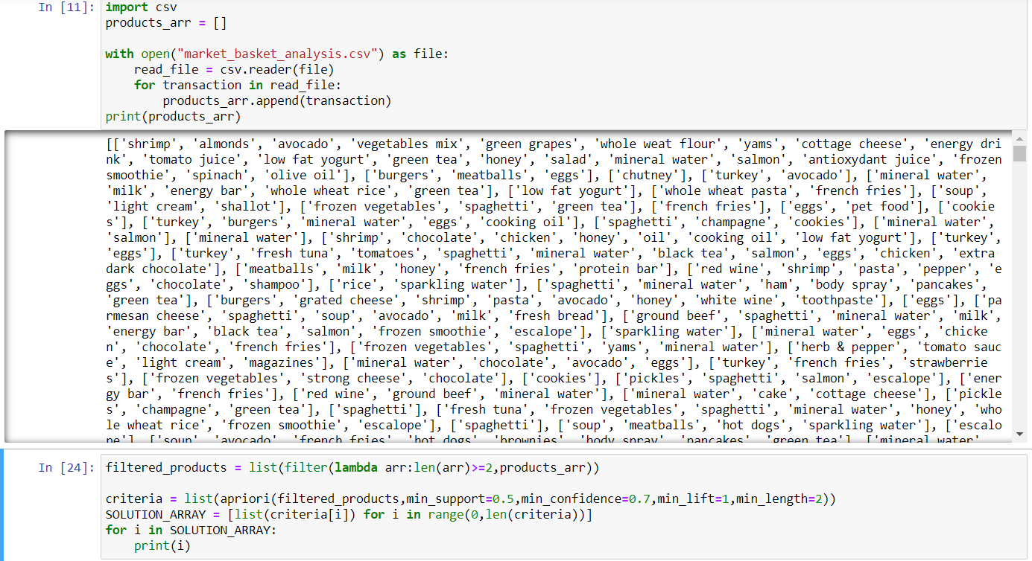

3)github link: <https://github.com/ganesh-sethu/association-rule-mining-using-apriori>